# Software Review Report

## How the team ensured the development quality of the software during the three sprints (test plans, etc).

## What processes were utilised to ensure adequate control of the quality of the development process.

## Describe the code testing process.

## How can the software be supported for future modification and refinements (comments, code documentation, development plans).

## Provide a mapping of the user requirement to the final software product (did you meet the clients expectations and requirements).

|  |  |
| --- | --- |
| User Requirements | Solution |
| Multi-platform report | We design the application using responsive approach which is more user friendly and SEO friendly. |
| Adapt prototype to responsive approach | In order to implement responsive approach to our website we utilize bootstrap. |
| Implement membership page | We implemented a form to capture people email and whether or not they want newsletter or newsflash notification. Figure 1 |
| Implement an option to remove subscription | We implemented a way for the employee to remove people from their newsletter or newsflash notification option. Figure 2 |
| Implement a password system for employee | To improve the security of the client database we have implemented a login system for employee. Figure 3 |
| Implement an admin system to update employee password | We implemented an admin system to update employee password. Figure 4 and 5 |
| Implement a rating system | We implemented a rating system which the user can rate the movie they like. Figure 6 |
| Implement streaming table | In order to keep the top 10 table updated we have implemented an auto refresh feature. |

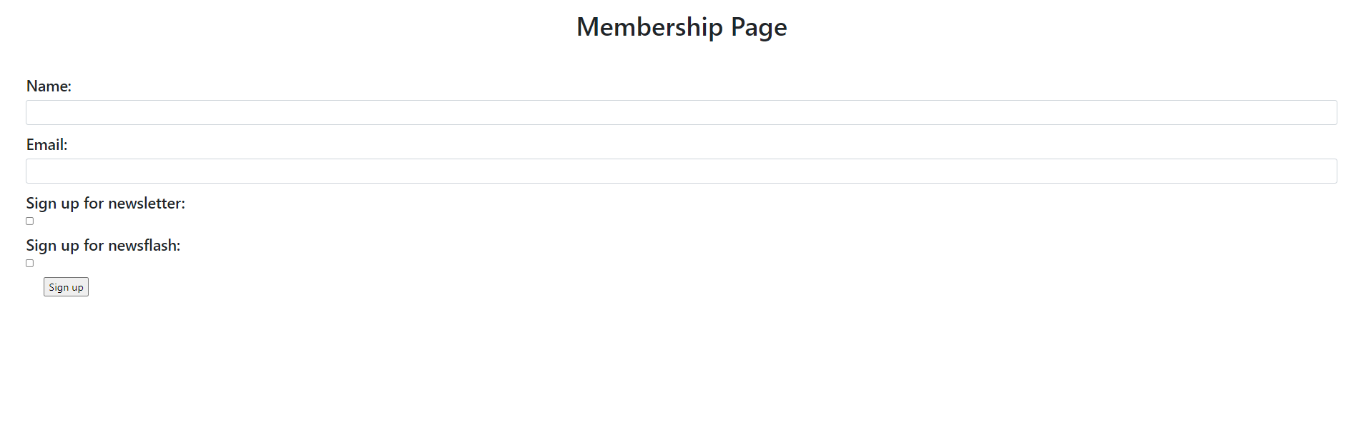

Figure

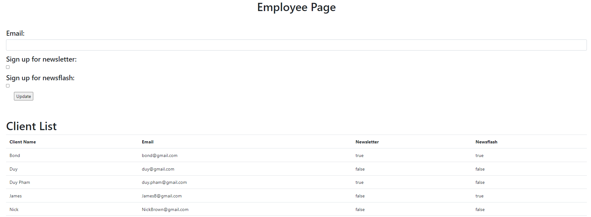

Figure

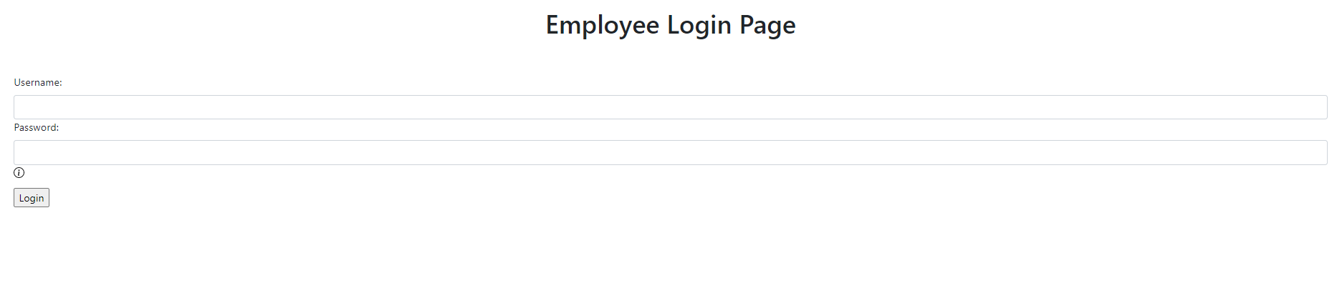

Figure

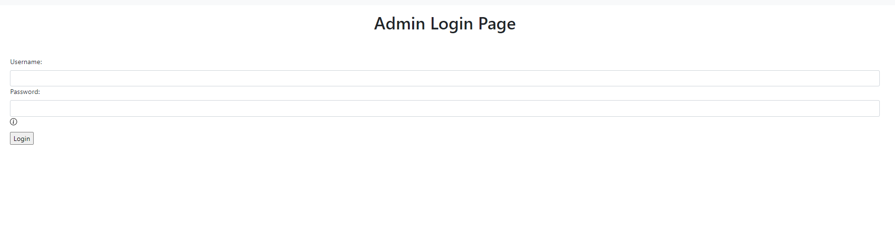

Figure 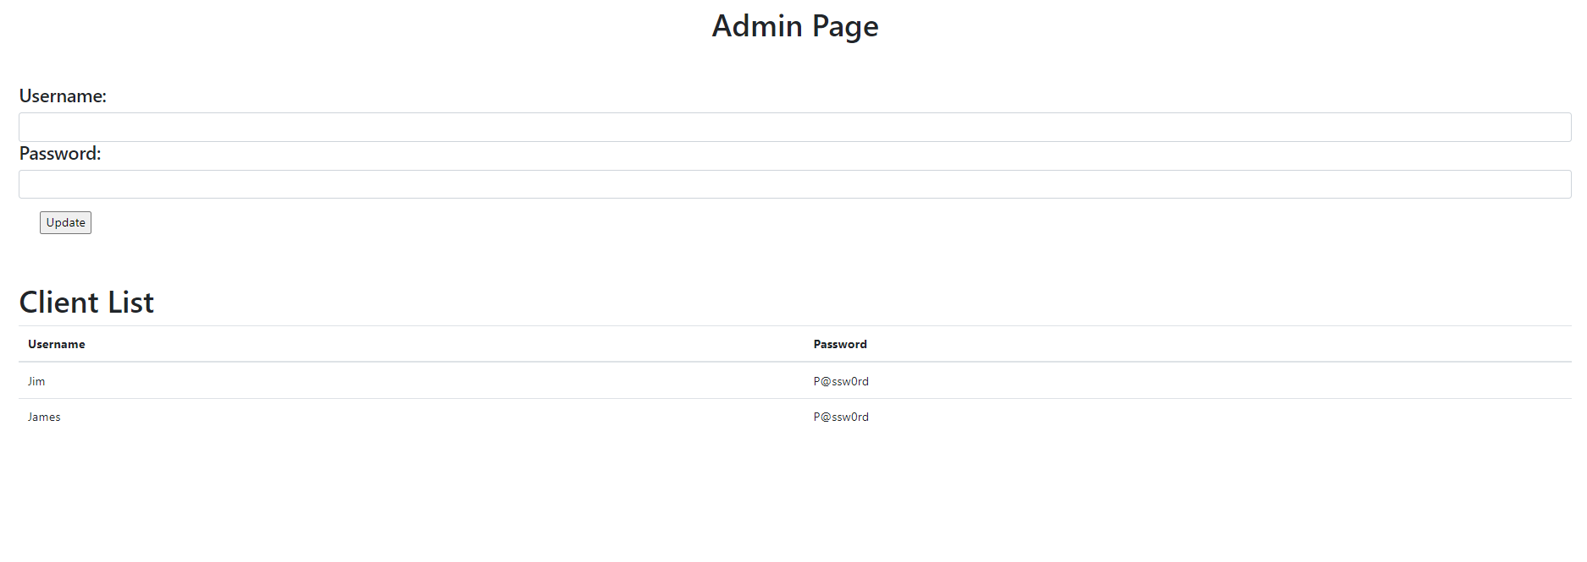

Figure



Figure